Enterprise Project Management System
For

Consulting Partner:

AstroWix India Project Solutions Pvt. Ltd.
A- 4&5, Logix Park
Sector 16, Noida - 201301, India
Phone: + 91-120 – 4033-854
Fax: +91 120 531 5766
E-mail:info@astrowix.com
Website:www.astrowix.com

Requirements and Specifications Document – EPM Deployment
Last Updated:
17 June 2009

Document Control Sheet

Version History
Version No | Release Date | Remarks
2.0 | 17-June- 2009 | In Progress

Document Author (s)
Author's Name | Role | Organization
Nidhi Jain | Functional Consultant | AstroWix India Project Solutions Pvt. Ltd.

Document Review
Reviewed By | Title | Organization
Saurabh Saroj | Project Manager | AstroWix India Project Solutions Pvt. Ltd.

Document Approval
Approval By | Title | Organization
Neeraj Mehta | AVP (Delivery) | AstroWix India Project Solutions Pvt. Ltd.

TABLE OF CONTENTS
1. Objective…........................................................................................................ | 4
2. Core Requirement…............................................................................................ | 4
2.1. PMO Requirement………………………............................................................... | 4
3. Approach.............................................................................................................. | 5
3.1. Current Approach…....................................................................................... | 5
3.2. Proposed Approach........................................................................................  3.3. Challenges Vs Mitigation Strategies…............................................................ | 5  6
4. Scope…............................................................................................................................. | 7
4.1. Functional Scope…………………………………................................................................ 7
4.1.1 Custom Enterprise Field Definitions……………………………………………………………… 11
4.1.1.1 Project Level……………………………………………………………………………………….. 11
4.1.1.2 Task Level……………………………….………………………………………………………….. 12
4.1.1.3 Project Web Access Views…………………………………………………………………..12
4.1.1.4 Resource Organization………………………………………………………………………..12
4.1.1.5 Working Times and Calendars……………………………………………………………..13
4.2. Technical Scope................................................................................................ | 14
4.2.1 Hardware Specification............................................................................... | 14
4.2.2 System Architecture…................................................................................ | 16
5. Dependency of each Template.................................................................................. | 17
6. PMO Structure........................................................................................................ | 17
7. Out of Scope............................................................................................................. | 18

Objective
The objective of the PMO function is to bring the skills required to efficiently and accurately monitor delivery and process compliance by different departments/functions.

Core Requirements
Unitech Wireless is planning to implement a Program Management Office solution to achieve the following objectives:
  - Effective Project Monitoring & Tracking Solution.
  - Configure the solution to provide reports on Project progress, Analysis and raise flags.
  - Configuring Central repository for documents with version control with role based access for each function
  - Building Communication workflow for effective Co-ordination amongst project stake holders
  - Escalation of Risk & Issues as per mutually agreed matrix
  - Defining customized reports and as per mutually agreed format
  - Defining Standard Reports.
  - Provide a web based front end to allow users (internal and external) to access the PM tool.
  - Definition & Customization of user interface – branding rule and role based access by users etc.
  - Include additional data fields to enhance Unitech Wireless’ decision making ability through the availability of information and to help with reporting & Business Intelligence.

Approach
………………………………………………………………………………………………………………………………………………
Current Approach
………………………………………………………………………………………………………………………………………………

On the basis of our discussion with Unitech Wireless, we figured out their current approach towards project execution as follows:
- Unitech Wireless is planning to rollout their mobile services across 8 circles by 1st December 2009
- Quantum of work increasing simultaneously across all functions, i.e.
  - IT
  - Regulatory
  - Network
  - Sales & Distribution
  - Marketing
  - Real Estate (Admin & Facilities)
  - Commercial
- They have got one single master project plan with individual function plan as its sub-tasks
- Simultaneous updating in master project plan is one big issue they are facing
- This leads to delay in giving quick real time project information
- Have multiple ownership for single project plan

………………………………………………………………………………………………………………………………………………
Proposed Approach
………………………………………………………………………………………………………………………………………………

We proposed Circle Wise approach for all Projects to eliminate their “Pain Areas”:
- Instead of having single project plan, we need to have hub / circle specific project plans
- Each project plan would include key activities/ milestones across functions which needs to be closely monitored
- Single ownership for individual project plans
- Will have centralized resource pool for optimum utilization
- Centralized and automated project tracking and monitoring
- Quantified reports with facts and data for senior management in line with business KPI’s

………………………………………………………………………………………………………………………………………………
Current Challenges Vs Mitigation Strategies
………………………………………………………………………………………………………………………………………………

Current Challenges | Mitigation Strategies
Cumbersome tracking and monitoring because of multiple ownership and complex project plan | Smooth tracking and monitoring through single ownership of every project plan and resources assigned to activities within that plan
Unavailability of quick real time data and hence wastage of time, energy and resource in report generation | Quicker reflection of real time data by achieving automatic generation of reports and dashboards - one time investment
No centralized resource pool | Centralized resource pool via EPM
No centralized Document Mgmt | Centralized / Project specific Document Mgmt with version control
No Risks and Issue Mgmt | Individual Project Risks and Issues Mgmt

Scope
The primary reason for the EPMS deployment is – The effective and efficient monitoring and management of the various projects undertaken by the Unitech Wireless meeting its requirements of the appropriate analyses on the project data / information throughout the entire life-cycle of these projects; and thereby equipping system users at the various identified levels with necessary reports and views enabling them to take the corrective actions when needed.
This will enable visibility of project status and deviations related to schedule and cost. This solution is web based; it will be accessed by all the concerned users for viewing various project status reports, thus minimizing the work of a project manager in creating
the same manually, With proper security mechanism in place; this solution will be able to provide proper insight to all the users handling the projects at different levels.
Unitech Wireless PMO would be the prime owner for this implementation and would oversee the complete implementation and monitoring of the EPM system.

………………………………………………………………………………………………………………………………………………

Functional Scope
………………………………………………………………………………………………………………………………………………

- All Projects will only be published from PMO.
- For 30th June go-live, EPM would be embraced for 8 Circles; there would be one PMO Executive for each circle. All PMO Executives would report to PMO Head Office.
- Approach for creating/monitoring/executing Project Plans:
  - Unitech Wireless Master plan to be monitored by PMO Executive for each circle.
  - All project templates to be created using 2 approaches:
- Centralized Approach
- Circle wise Approach
- Templates to be created for all work streams. Need to prioritize them keeping 30th June go-live in notice.
- Circle wise project templates would be created for the following work streams:
  - Networks Roll-Out (total no. of templates = 2)
  - Sales & Distribution (total no. of templates = 2)
  - Regulatory (total no. of templates = 2)
- Centralized project templates would be created for the following work streams:
  - Marketing (needs more time to analyze)
  - IT (needs more time to analyze)
  - Networks Central (total no. of templates = 1)
  - Real Estate Central (total no. of templates = 1)
  - Sales & Distribution Central (total no. of templates = 2)
- Details for Finance stream yet to be received.
- Following Reports to be created for 30th June go-live:
- COCO FOFO Tracker
- Distribution Tracker PMO
- Real Estate Tracker
- PMO Overall Dashboard
- PMO Dashboard – IT
- PMO Dashboard – Network with HLR & GSM
- PMO Dashboard – Real Estate
- PMO Review – Regulatory
- Two Enterprise Calender to be created named:
  - 6 days calendar (5 days working times, from 9 30 am to 6 pm with half an hour lunch break, Saturday as half day that is 9 30 till 1 00pm)
  - 7 days calendar (7 days working times, from 9 30 am to 6 pm with half an hour lunch break)
- Provide a web based front end to allow users (internal and external) to access the PM tool.
- The Enterprise Resource Pool will be generated using the Windows Active Directory Synchronization process. If needed for remote access (users not part of Unitech domain), we will extend one site for FBA (Forms Based Authentication).
- A central as well as project level repository with version control feature will be created in the system wherein all the users will be able to store and share their documents, files and other communications along with role based access for each function.
- Regular Escalation of Risk & Issues as per mutually agreed matrix.
- Standard security module of EPM will be implemented to maintain confidentiality of the information stored in this system.
- The system will incorporate many levels of security with respect to system users and system data as per hierarchy defined by Unitech Wireless. The documents will have security in terms of read-only, modify and delete permissions.
- EPM security model will be extended to incorporate the user defined security hierarchy.
- EPM will allow the user to replace the resources for a given task and will also maintain the information of the work status of the all the resources associated with that task.
- Default Assignment Owner of each Assignment will be the Resource assigned to the individual Tasks.
- The knowledge base will include issue, risk and deliverable, calendar, tasks, events, announcements, customized web parts, discussion forum and other relevant information related to all the projects.
- Unitech Wireless wants EPM Use case scenarios supported with diagrams.
- Alerts and reminders
  - The system has inbuilt feature of “Alerts” and “Reminders” to provide information about the project schedule to the assigned resources
  - Alerts for Activity delay to Team Member and Project Manager
  - Alert before 4 days of completion of activity or as per time scheduled agreed amongst various stream owners.
- Two Days Training will be imparted by AstroWix.

This below mentioned tabular section contains both Scope and design information pertaining to the solution to be deployed. The tables in the first two tables primarily contain scope information along with some design information. In fact, all the tables that follow contain mostly or only design information. Throughout this document, answering yes to any of the questions obligates the Business Analyst to describe the requirement further in the adjacent cell. The Business Analyst must determine the content values for all the line items in these first two tables knowing that he / she can revise these with the solution stakeholders as they learn more about the platform and that some of the answers may not be clear early in the process.
Requirement | Value
System Archetype | Multi Server Architecture
Total number of Templates | 10*  *Subject to change in consultation with the business
Total number of active projects to accommodate | 1000
Average number of tasks per project | 500 – 1500
No. of Documents for the Doc Lib. | -
Total system users | -
Total number of Reports | 8
Total material resources | NA
Total cost resources | NA
Total generic resources | -
Project work spans multiple locations? (Yes/No) | Yes
List Language support | EN-India
Master Projects allowed? (Yes/No) | Yes
Multi currency? (Yes/No) | No
Forms Authentication (Yes/No) | Need to confirm

Custom Enterprise Field Definitions
- Project Level
Field Unique Name | Field Type | Required? | Value List | Description and notes
Hub
Circle
Project Status | Graphical Indicator like Traffic Signals | No |  | Tool Tip:  - Not Started  - On Going  - Completed  - On Hold  - Abandoned
Project Schedule Status | Graphical Indicator like Traffic Signals | Yes |  | Tool Tips:  - On Time  - Ahead  - Delayed

- Task Level
Field Unique Name | Field Type | Required? | Value List | Description and notes
Zone | Text |  | -
Town | Text |  | -
Vendor Initials | Text
Anchor_Nonanchor | Text
SACFA | Text |  | - Yes  - No
Task Status | Graphical Indicator like Traffic Signals | Yes |  | Tool Tip:  - Not Started  - On Going  - Completed  - On Hold  - Abandoned
Task Schedule Status | Graphical Indicator like Traffic Signals | No |  | Tool Tips:  - On Time  - Ahead  - Delayed

- Project Web Access Views
View Name | Fields | Description
– Work – Project Center |  | Standard project view
– Tracking – Project Center |  | Standard project view
– Summary – Project Center |  | Standard project view
– Resource summary  – Resource Center |  | Standard project view with all XX custom Enterprise Project fields added

- Resource Organization
Requirement | Value
Use an RBS? | No
Resource Rates | No
Other unique identifiers for Resources | Yes [refer to Custom Enterprise Field Definitions – Project Level section]
Use Generic resources | Yes
Use Cost Resources? | No

- Working Times and Calendars
Requirement | Value
6 days calendar (5 days working times, from 9 30 am to 6 pm with half an hour lunch break, Saturday as half day that is 9 30 till 1 00pm) | from 9 30 am to 6 pm with half an hour lunch break, Saturday as half day that is 9 30 till 1 00pm
7 days calendar (7 days working times, from 9 30 am to 6 pm with half an hour lunch break) | from 9 30 am to 6 pm with half an hour lunch break

………………………………………………………………………………………………………………………………………………

Technical Scope
………………………………………………………………………………………………………………………………………………

Suggested Hardware Specification for EPM Deployment
1. | For Server Deployment | Server 1: Project Server (2Nos) : Application and Front End Server  Server 2: Database Server (2Nos) and Report Server
  Hardware | Description
  CPU | Quad-Core Xeon (2.0 GHz or higher)
  RAM | 8 GB or higher
  Disk | 100 GB
  Network cards | 100/1000 Mbps recommended
  Operating system | Microsoft Windows 2008 Server Enterprise Edition
  Hardware | Description
  CPU | Quad-Core Xeon (2.0 GHz or higher)
  RAM | 16GB
  Disk | 260 GB * 2 Nos.
  Network cards | 100/1000 Mbps recommended
  Operating system | Microsoft Windows 2008 Server Enterprise Edition
  Database | Microsoft SQL 2008 Enterprise Edition

Microsoft Project Server 2007 Architecture

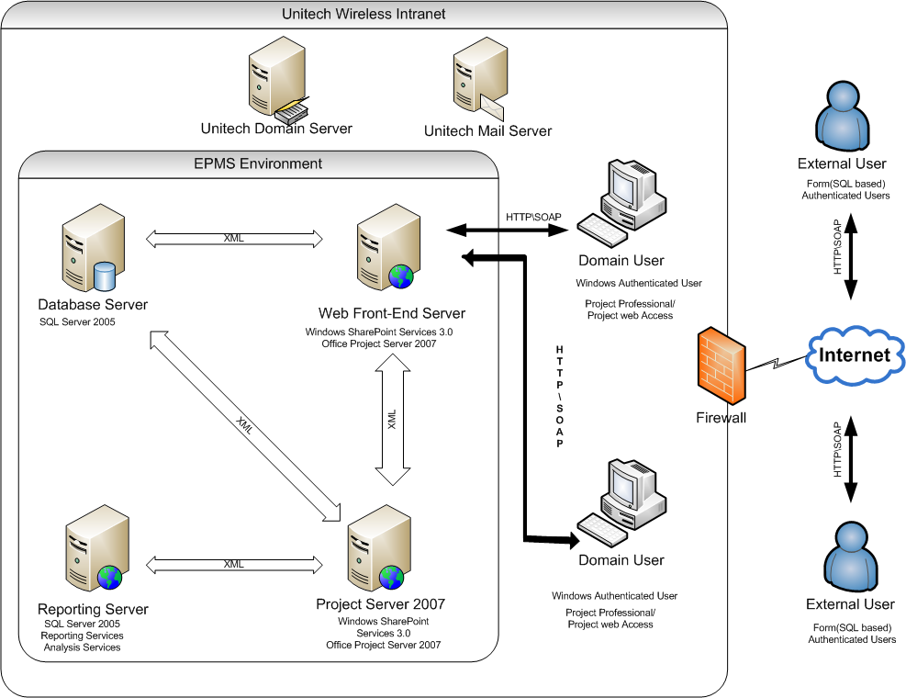

- Project Server URLS
Requirement | Value
Project Server Intranet URL – Project Server | http://epms.unitechwireless:8080/projectserver

- Notifications (Project Server)
Requirement | Value
From Address.
Company Email address.
SMTP Server
SMTP Port | 25
Daily run time | 0:00

Dependency of each templates / projects
Need to be decided

PMO structure
Need to be decided
In the Unitech Wireless all the Standard EPM Roles will be customized as per Unitech Wireless requirements; and will be configured in 1st phase till 30th June 2009 based on the decisions taken by Unitech Wireless at appropriate stages.
However, initially the standard EPM Roles based access rights and privileges will be used to test the system and come up with the appropriate conclusions.

Requirement | Value
Define who has access to all project data across the enterprise.
By role, Describe the criteria by which an Executive, Project Manager, Resource Manager, Team Lead, or Resource has access to project data.
By role, Describe the criteria by which an Executive, Project Manager, Resource Manager, Team Lead, or Resource has access to resource data.
Define special roles of internal or extranet users and the data access they should have.

Out of Scope
Following functionality / features / attributes, etc. will not be considered as part of the Unitech Wireless PM Tool Go Live Date ie. 30th June 2009:
  - Timesheet Integration
  - Resource Breakdown Structure (RBS)
  - Outlook Synchronization
  - Data Analysis Views
  - Customize Workflows
  - Configure for External Division
  - Integration PM tool with other ERP System
  - Customize Email Alerts and Email Subscription

